**Name: Score:**

**Student No/Class:**

**My Dream Destination**

This week and the next, we are learning to describe a country we want to visit in the future, especialy the one where we want to build our career at. We are also learning to explain the reasons why we are interested with the country, and most importantly what cultural aspects of the country we need to know. To help you research the information effectively, you are guided by a KWL table. By completing the table, you are expected to satisfy your curiousity on certain aspects of your dream country.

In the previous lesson, you have reviewed and explained some cultural aspects of our beloved Indonesia, i.e., how Indonesian people start conversations, conduct conversation, show emotion, and how they dress and view the concept of punctuality. To help you strat the information research regarding your dream country, you can think of these four cultural aspects. Of course, you are welcome to research more aspects.

In the third page of this handout, you have a venn diagram to help you identify the similarities and/or differences between the cultural aspects of your dream country and those of Indonesia or your country of origin. On the Mid-term exam, you will use both your completed KWL table and ven diagram to help you compose an essay. Then, in its turn, you will use your Mid-term essay to work on your third speaking/video project. So, be sure to:

1. bring this handout (all pages) to the mid-term exam. Your handout should contain ONLY information you need to put in the KWL table and venn diagram. You are **NOT ALLOWED to write your draft for the essay in this handout**.
2. get the scored handout and mid-term essay for the purpose of completing speaking/video 3 project.

***Bring this handout with you to the Mid-term Exam***

Name:

Student No./Class:

**My Dream Destination KWL Chart**

Select a country you really want visit in the future. In the **first** column, write what you already **KNOW** about the country. In the **second** column, write what you **WANT** to know about the country. After you have completed your research, write what you **LEARNED** in the third column. You will use your KWL table as an outline for your Mid-term essay. Be sure to BRING this 3-page handout to the Mid-Term Exam.

|  |  |  |
| --- | --- | --- |
| What I  Know | What I  Want to know | What I  Learned |
|  |  |  |

Name:

Student No./Class:

|  |  |  |
| --- | --- | --- |
| What I  Know | What I  Want to know | What I  Learned |
|  |  |  |

Name:

Student No./Class:

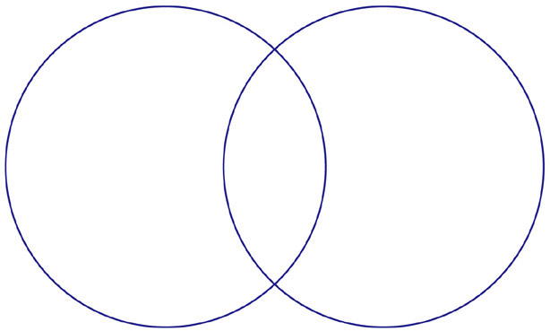

**Name of Dream Country:**

**TITLE**

**TITLE**

**KWL Table Rubric**

|  |  |  |  |  |
| --- | --- | --- | --- | --- |
| **Criteria** | **4** | **3** | **2** | **1** |
| **Critical Thinking** | Student's comments are in depth and show evidence of critical thinking. | Student's ideas show evidence of critical thinking. | Student's ideas are short and shallow. | Student's ideas do not show evidence of critical thinking. |
| **Connecting to Prior Knowledge** | Student stated more than 4 things he/she knows or thinks he/she knows about the topic in the "K" column. | Student stated more than 3 things he/she knows or thinks he/she knows about the topic in the "K" column. | Student stated more than 2 things he/she knows or thinks he/she knows about the topic in the "K" column. | Student stated nothing related to what he/she knows or thinks he/she knows about the topic in the "K" column. |
| **Purpose for Learning** | Student listed 4 or more questions in the "W" part of the chart. | Student listed 3 questions in the "W" part of the chart. | Student listed 2 questions in the "W" part of the chart. | Student listed 1 or no questions in the "W" part of the chart. |
| **Inference** | Student accurately infers answers to 4 of his/her questions. | Student accurately infers answers to 3 of his/her questions. | Student accurately infers answers to 2 of his/her questions. | Student accurately infers answers to 1 or none of his/her questions. |
| **Comprehension** | Student coherently stated 4 or more answers to learning questions in the "L" part of the KWL. | Student coherently stated 3 or more answers to learning questions in the "L" part of the KWL. | Student coherently stated 2 or more answers to learning questions in | Student coherently stated 1 or more answers to learning questions in the "L" part of the KWL. |

**Total points: 20; Points will be converted into 5 in the excel sheet for grades.**